**Project Design Phase-II**

**Technology Stack (Architecture & Stack)**

|  |  |
| --- | --- |
| Date | 31 January 3035 |
| Team ID | LTVIP2025TMID48259 |
| Project Name | Plugging into the Future: An Exploration of Electricity Consumption Patterns using Tableau |
| Maximum Marks | 4 Marks |

**Technical Architecture:**

The solution is focused on analyzing electricity consumption using Tableau. The architecture includes:

* Data ingestion from CSV files
* Preprocessing via Python (pandas)
* Visualization through Tableau
* Local system or cloud-hosted Tableau deployment

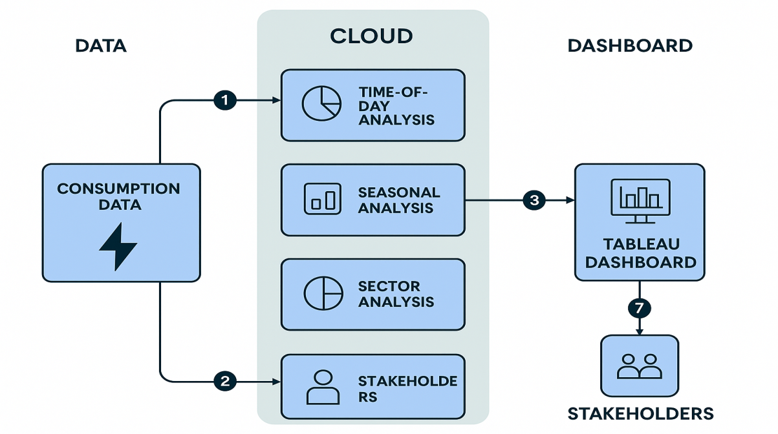

**Table-1 : Components & Technologies:**

|  |  |  |  |
| --- | --- | --- | --- |
| **S.No** | **Component** | **Description** | **Technology** |
|  | User Interface | Interaction with the dashboard | Web Browser (Tableau Web UI) |
|  | Application Logic-1 | Preprocessing: cleaning, formatting data | Pandas,Python |
|  | Application Logic-2 | Integration with Tableau | Tableau Desktop, Tableau Public |
|  | Application Logic-3 | Time-based, sectoral and seasonal logic representation | Tableau Filters, Calculated Fields |
|  | Database | Structured CSV Data | CSV, Excel |
|  | Cloud Database | Optional cloud-hosted Tableau Public data | Tableau Cloud |
|  | File Storage | Electricity usage dataset storage | Local File System / Cloud Storage |
|  | External API-1 | (Optional for future) Integration with weather API | OpenWeather API |
|  | External API-2 | (Optional) Geolocation data enrichment | Google Maps API |
|  | Machine Learning Model | (Optional) Forecasting consumption trends | Scikit-learn / Prophet (Optional) |
|  | Infrastructure (Server / Cloud) | Hosting Tableau and data processing | Local PC / Tableau  Online / Cloud |

**Table-2: Application Characteristics:**

| **S.No** | **Characteristics** | **Description** | **Technology** |
| --- | --- | --- | --- |
|  | Open-Source Frameworks | Data processing framework | Python, Pandas |
|  | Security Implementations | Data stored securely, Tableau access controls, file protection | OS-level encryption, Tableau user roles |
|  | Scalable Architecture | Modular dashboard design; can scale with new datasets or APIs | Tableau Workbooks, Filters |
|  | Availability | Hosted online (Tableau Public) or local offline version for access | Tableau Online / Public |
|  | Performance | Dashboards optimized using data extracts and filters | Tableau Extracts, Indexed Filters |